Java Notes
- Difference between C++ and Java
C++ is a high-level and general-purpose programming language that was developed by Bjarne Stroustrup in 1979. It is an extension of the C programming language. It allows us to define our own data types and manipulate them using functions and methods. It is also known as an object-oriented programming language. C++ is commonly used to develop system software, embedded systems, game development, scientific computing, and high-performance applications.

Java is a high-level, object-oriented programming language widely used in developing websites, mobile applications, web applications, desktop applications, games, and more. Java applications can run on any Java virtual machine (JVM) as they are generally compiled to bytecode.

Feature | Java | C++
Platform | Platform-independent ("Write Once, Run Anywhere") using JVM | Platform-dependent (compiled for a specific OS)
Compilation | Compiled to bytecode and runs on the JVM (Java Virtual Machine) | Compiled directly into machine code
Memory Management | Automatic memory management with Garbage Collection | Manual memory management using new and delete
Pointers | Does not support explicit pointers (for safety) | Supports pointers and pointer arithmetic
Multiple Inheritance | Not supported for classes (achieved using interfaces) | Supported directly
Object-Oriented | Mostly pure object-oriented (everything is inside classes) | Supports both procedural and object-oriented programming
Operator Overloading | Not supported (except for + with strings) | Supported
Header Files | No header files | Uses header files (.h or .hpp)
Performance | Slightly slower because it runs on the JVM | Generally faster because it runs as native code
Exception Handling | Built-in and includes checked exceptions | Supports exceptions but no checked exceptions
Portability | Highly portable across different platforms | Requires recompilation for different platforms
Security | More secure due to JVM and no direct pointer access | Less secure because of direct memory access and pointers
Common File Extensions | .java | .cpp, .cc, .cxx

At compile time, the Java file is compiled by Java compiler (It does not interact with OS) and converts the Java code into bytecode.
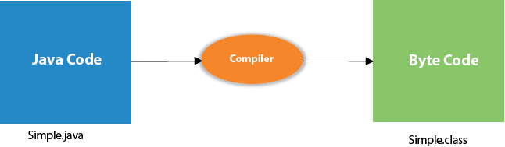
What happens at runtime?
At runtime, the following steps are performed:
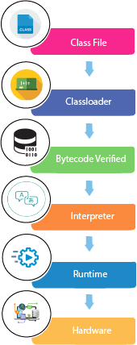
Classloader: It is the subsystem of JVM that is used to load class files.
Bytecode Verifier: Checks the code fragments for illegal code that can violate access rights to objects.
Interpreter: Read bytecode stream then execute the instructions.

